A
PROJECT REPORT
ON
FitSync: Gym Management Android App



Academic Year
2024-2025

Under the Guidance of

Associate Professor. Dr. Preetjot Kaur

Submitted by

Aarushi- 70022400560
Aryan -70022400566

Department of STME, Computer Engineering
SVKM’s NMIMS (Deemed-to-be-University)
Mukesh Patel School of Technology Management & Engineering, Chandigarh campus

Index

Page No.
- Introduction 3

- Methods and Material 4

- Block Diagram 5

- Component List 5-6

- Working Model 6-7

- Project Execution Steps 8

- Results 9

- Applications 9

- Conclusion & Future Scope 10

- References 11

Acknowledgement 11-12

- Introduction

About Project:
FitSync is a native Android application, written in Java, that digitises the day-to-day operations of a gym. It brings the three groups of people involved in running a gym (members, trainers and administrators) into one app, and gives each group its own dashboard and set of activities. The application is designed to make routine gym activities easier to access from a smartphone and to reduce dependence on separate paper records. Its role-based structure keeps member activities, trainer responsibilities and administrative tasks organised within one system.
Members can log workouts, check in, follow their progress and renew their membership. Trainers can see the members assigned to them, create workout plans and review progress. Administrators can manage members and trainers, assign trainers to members, approve membership renewals and view gym reports. All data is stored on the device in an SQLite database, and passwords are protected with salted PBKDF2 hashing. By maintaining these functions in a common application, FitSync helps users access relevant information without having to coordinate every update manually. The local database supports the core features even without a separate server, making the project suitable as a prototype for small fitness facilities.
Objectives
- Replace manual registers with a single mobile app for members, trainers and administrators. This reduces repetitive paperwork and makes routine gym information easier to retrieve.
- Provide role-based access so every user sees only the features meant for them. Role-based dashboards also help prevent users from accessing screens that are not relevant to their responsibilities.
- Let trainers assign and track workouts, and let members monitor their own progress. Recorded exercise completion provides a simple way to review consistency over time.
- Simplify attendance tracking and membership renewal handling. The renewal request workflow gives administrators a clear process for handling member requests.
- Keep user credentials secure. Salted password hashing is used rather than storing passwords as readable text.

- Methods and Material

The project follows an incremental development approach. Requirements were identified for each role, the screens and database were designed, and the app was then built and tested module by module. The main methods and materials are listed below. The incremental approach made it possible to implement and verify one group of features before moving to the next. The design also separates the user interface, session handling and database operations so that each part has a clear responsibility.
- Platform and language: Native Android app written in Java using Android Studio and Gradle (minimum SDK 24, target SDK 37). Java handles application logic and event processing, while Android Studio provides the development, debugging and emulator environment.
- User interface: XML layouts using AppCompat, ConstraintLayout and Material components, with a dark navy and blue theme. Lists of members, trainers and requests are built dynamically as cards. The consistent colour palette and reusable interface components help maintain a uniform appearance across the application. Card-based lists make records easier to scan on a mobile screen.
- Navigation: Explicit Intents move the user between the 19 activities of the app. This activity-based navigation connects screens according to the user's workflow and role.
- Data storage: An SQLite database (fitsync.db) managed by DatabaseHelper (SQLiteOpenHelper) with seven tables: users, trainer_assignments, workout_plans, workout_exercises, attendance, memberships and renewal_requests. The tables organise account information, trainer assignments, workout details, attendance records and membership renewal requests. DatabaseHelper centralises database creation and common insert, read and update operations.
- Session handling: Shared Preferences (FitSyncSession) keeps the logged-in user's id, name and role until logout. This allows the app to identify the current user and display the appropriate dashboard after navigation between activities.
- Security and validation: Passwords are hashed with PBKDF2WithHmacSHA1 using a random 16-byte salt and 120,000 iterations. Sign-up needs a @gmail.com or @nmims.in email and a password of at least 8 characters. The random salt helps ensure that identical passwords do not produce identical stored hashes. Input validation also reduces the chance of incomplete or incorrectly formatted registrations.
- Testing: A local JUnit test and AndroidX instrumented tests run on an Android emulator. Testing focused on core database operations and important user-interface behaviour to check that the main workflows operate as expected.

- Block Diagram
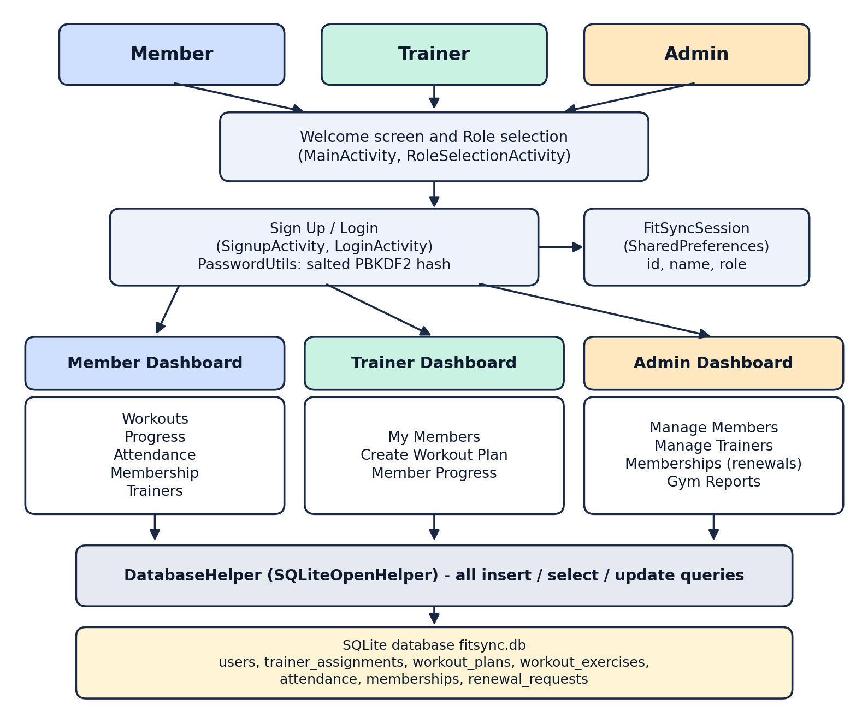
Figure 1: Block diagram of the FitSync application

- Component List

Sr. No. | Name of Algorithm/Dataset/Tool | Source | Cost if any
1 | Java | Programming language for all app logic | Open source (OpenJDK, Android SDK)
2 | Android Studio and Gradle | IDE and build system | developer.android.com
3 | AndroidX AppCompat, ConstraintLayout, Material | UI libraries | Google Maven repository
4 | SQLite (SQLiteOpenHelper) | Local database | Android platform
5 | SharedPreferences | Login session storage | Android platform
6 | PBKDF2WithHmacSHA1 | Salted password hashing | Java javax.crypto
7 | JUnit, AndroidX Test, Android Emulator | Testing | Android Studio
Total Cost: Nil (all tools are free or open source)

- Working Model
When the app opens, the welcome screen leads the user to Sign Up or Login, and a role selection screen can open the Member, Trainer or Admin dashboard. After a successful login the session is saved and the user is taken to the dashboard for their role. The activities of each role are described below. The application follows a role-based workflow: users first enter through the welcome screen, authenticate, and then work from the dashboard assigned to their role. Information entered through the different modules is stored in the local database and reused by related screens.
Authentication
- Sign Up: Collects name, email, password, confirmation and role, validates them and stores a salted password hash. Required fields are checked before an account is created, helping avoid incomplete registration records.
- Login: Checks the email and password against the stored hash and opens the dashboard that matches the role. Successful authentication establishes the user's session and directs them to the appropriate role-specific home screen.
Member module
- Member Dashboard: Greets the member and gives shortcuts to all member features. The dashboard acts as a starting point, reducing the number of steps needed to reach frequently used functions.
- Workouts: Lets the member add personal exercises with sets, reps and weight, shows exercises assigned by the trainer, and allows each to be marked completed. The workout list can therefore serve as a basic record of planned and completed exercise sessions.
- Progress: Shows completed exercises against the total number of exercises. This summary gives members a quick indication of how much of their listed workout they have completed.
- Attendance: Records a check-in and shows the number of visits and the last check-in. The visit count and latest check-in help members review their attendance history.
- Membership: Shows the current plan, status and end date, and lets the member request a renewal (only one request can be pending). Displaying the plan and its end date helps members understand their current membership status before requesting an extension.
- Trainers: Lists the trainers, shows whether a trainer is assigned to the member and offers a contact option. This provides members with visibility into the available trainers and their assignment status.
Trainer module
- Trainer Dashboard: Home screen with access to the trainer features. It brings member-management and workout-planning functions together in one place.
- My Members: Lists the members the admin has assigned to the trainer. This assignment-based list helps trainers focus on the members for whom they are responsible.
- Create Workout Plan: Lets the trainer choose an assigned member and add an exercise with sets and reps, which then appears in that member's workouts. The saved plan becomes available to the selected member, supporting coordination between trainer guidance and member activity.
- Member Progress: Lets the trainer review the progress of assigned members. Reviewing completion information helps trainers identify activity patterns and follow up where additional guidance may be useful.
Admin module
- Admin Dashboard: Central screen for managing the gym. The dashboard provides a central entry point for the administrative functions needed to operate the gym.
- Manage Members: Lists members and assigns each one an active trainer. Assignments connect members with trainers and help organise the trainer's member list.
- Manage Trainers: Lists registered trainers with their details. Keeping trainer records in one place makes it easier to review the available training staff.
- Memberships: Shows renewal requests and lets the admin approve or reject them. The approval workflow allows renewal requests to be processed in a controlled manner rather than being treated as automatically accepted.
- Gym Reports: Shows total members, total trainers, active memberships and today's check-ins. These summary figures offer administrators a quick overview of gym activity and membership status.

- Project Execution Steps

The project was carried out in the following steps. Each stage was completed in sequence, with implementation and testing used to identify issues before finalising the build.
- Analysed the requirements of members, trainers and administrators and listed the features for each role. This planning stage helped define the boundaries of each module and reduce overlap between user roles.
- Created the Android Studio project (Java, minimum SDK 24) and set up the AppCompat, Material and ConstraintLayout dependencies in Gradle. The initial setup established the libraries and SDK configuration required to compile and run the app.
- Designed the screens as XML layouts, with a common dark theme, card and button styles and the FitSync logo. Reusable styles were applied to keep the screens visually consistent and improve readability on different device sizes.
- Designed the SQLite schema with seven tables and wrote DatabaseHelper with all the queries the app needs. The database design was aligned with the main workflows so that related information could be stored and retrieved systematically.
- Implemented Sign Up and Login with PasswordUtils for hashing, and FitSyncSession for the login session. These components support account verification and preserve the identity and role of the active user during a session.
- Built the member activities: dashboard, workouts, progress, attendance, membership and trainers. Each member feature was connected to the relevant database operations so that workout, attendance and membership information could be displayed or updated.
- Built the trainer activities: dashboard, my members, create workout plan and member progress. The trainer screens were linked to assigned-member records to keep workout planning focused on the correct users.
- Built the admin activities: dashboard, manage members, manage trainers, memberships and gym reports. Administrative functions were added to manage records and process requests from a central dashboard.
- Wrote and ran unit and instrumented tests on an Android emulator and fixed the issues found. The tests were used to check database behaviour and key interactions, and issues identified during execution were corrected.
- Built the debug APK and ran the app on the emulator. The final emulator run provided a practical check of the compiled application and its main navigation flow.

- Results

The automated tests recorded for the project finished with no failures: one local unit test and three instrumented tests run on an Android emulator (a database check, a cursor column check and a UI test that adds an exercise on the workout screen). The debug APK was also built successfully. These checks provided initial evidence that the main database and interface workflows were functioning in the tested environment. The successful debug build also confirmed that the project could be compiled and launched for demonstration.
The implemented features of the application are: Together, these features demonstrate the core workflow from user registration through daily gym activity and administrative review:
- Registration and login for the Member, Trainer and Admin roles, with hashed passwords.
- Admin assignment of trainers to members, so trainers see only their own members.
- Trainer-created workout plans that appear in the member's workout list.
- Exercise completion that feeds the member's progress summary.
- Check-in with visit count and last visit date.
- Membership renewal requests with admin approval or rejection.
- Gym reports showing total members, trainers, active memberships and today's attendance.

- Application

1. Gyms and fitness centres: replaces paper registers for membership, attendance and trainer assignment.

2. Personal training studios: trainers can plan workouts and monitor the progress of their clients.

3. Colleges, hostels and corporate wellness centres: a simple tool for small fitness facilities.

4. A base for a larger fitness platform: the role-based structure can be extended with cloud sync and analytics.

9.Conclusion & Future Scope

FitSync shows how the daily work of a gym can be handled in one Android app. Role-based dashboards keep each user focused on their own tasks, the SQLite database stores all records on the device, and salted password hashing protects user accounts. Together, the 19 activities cover registration, workouts, progress tracking, attendance and membership management. The project demonstrates how Android development, local database management, role-based navigation and password protection can be combined to address a practical management need. Members can record and review their activities, trainers can prepare plans for assigned members, and administrators can manage membership and attendance information through dedicated dashboards. As a prototype, FitSync provides a foundation that can be improved with additional testing and online services.
Future scope The following enhancements could make FitSync more scalable, convenient and informative in a real-world deployment:
- Cloud database and sync so data is shared across devices. Cloud synchronisation would allow authorised users to access updated records across multiple devices and reduce dependence on a single phone.
- Online payment for membership plans and renewals. Integrating a secure payment gateway could make membership renewals more convenient and provide a digital transaction record.
- Push notifications for membership expiry and workout reminders. Notifications could remind members about upcoming expiry dates, scheduled workouts and pending renewal decisions.
- QR-code check-in and progress charts for members. QR-based check-ins could speed up attendance entry, while visual progress charts could make workout history easier to understand.
- Admin approval of new trainer and admin accounts before they become active. Approval controls could strengthen account administration by ensuring that new privileged accounts are reviewed before access is granted.
- Machine learning based workout recommendations and analytics from workout and attendance data. With suitable data and careful evaluation, machine-learning techniques could suggest workout plans or highlight attendance patterns for trainers and administrators.

10.References

1. Android Developers, "Introduction to activities", https://developer.android.com/guide/components/activities/intro-activities

2. Android Developers, "Save data using SQLite", https://developer.android.com/training/data-storage/sqlite

3. Android Developers, "Save key-value data with SharedPreferences", https://developer.android.com/training/data-storage/shared-preferences

4. IETF, RFC 8018: "PKCS #5: Password-Based Cryptography Specification Version 2.1", https://www.rfc-editor.org/rfc/rfc8018

5. Android Developers, "Test apps on Android", https://developer.android.com/training/testing

Acknowledgement
We would like to express our sincere gratitude to our project guide, Dr. Preetjot Kaur, for her valuable guidance, continuous support, encouragement, and constructive feedback throughout the development of our project, FitSync: Gym Management Android App. Her insights and suggestions helped us understand the project requirements, improve our approach to implementation, and complete the various modules of the application effectively. Her guidance played an important role in enhancing our technical knowledge and ensuring the successful completion of this project.
We would also like to extend our heartfelt thanks to the Department of STME, Data Science and Machine Learning, SVKM’s NMIMS, Mukesh Patel School of Technology Management & Engineering, Chandigarh Campus, for providing us with the necessary academic support, resources, facilities, and learning environment required to undertake this project. The knowledge and practical skills gained through our academic coursework helped us apply our understanding of Android application development, Java programming, database management, user interface design, and software testing to a real-world problem.
We are grateful to all the faculty members who have contributed to our learning journey and encouraged us to explore innovative technological solutions. Their teaching and motivation helped us develop a better understanding of software development principles and their practical applications.
We would also like to acknowledge the efforts and cooperation of everyone who directly or indirectly supported us during the planning, design, implementation, and testing of FitSync. Working on this project provided us with an opportunity to strengthen our programming skills, understand the importance of efficient database management, and develop a role-based mobile application to simplify gym operations, including workout planning, attendance tracking, progress monitoring, and membership management.
Finally, we would like to thank our institution, our project guide, and everyone who supported us throughout this journey. Their encouragement, valuable suggestions, and academic support helped us overcome challenges, improve our work, and successfully complete and document this project. This experience has been an important step in our technical and academic development.

